

Requirement & Design Specification

**Jewelry Auction**

**Version: 1.0**

– Ho Chi Minh Campus, 2024 –

Contents

I. Overview 4

1. User Requirements 4

1.1 Actors 4

1.2 Use Cases 5

2. Overall Functionalities 9

2.1 Screens Flow 9

2.2 Screen Descriptions 10

2.3 Screen Authorization 10

2.4 Non-UI Functions 11

3. System High Level Design 13

3.1 Database Design 13

3.2 Code Packages 14

II. Requirement Specifications 18

1. Search for jewelry 19

2. View coming auction 20

3. View blog 20

4. Sign In 21

5. Signs Up 22

6. Removes jewelry 22

7. Create blog 24

8. update information jewelry 25

9. View Information 25

10. Jewelry Valuation 26

11. Approve Valuation 27

12. Add new staff/manager 27

13. Update staff/manager 28

14. View bid history 29

15. Send jewelry valuation to manager 29

III. Design Specifications 30

1. Authentication 30

1.1 Sign In 30

1.2 Sign Up 31

2. Product 32

2.1 Request jewelry 32

2.2 Auction 34

3.2 Collections Management 37

IV. Appendix 38

1. Assumptions & Dependencies 38

2. Limitations & Exclusions 38

3. Business Rules 39

# I. Overview

## 1. User Requirements

### 1.1 Actors

| **#** | **Actor** | **Description** |
| --- | --- | --- |
| 1 | Admin | The system administrator. Responsible for overall system configuration, user management (creating accounts for managers, staff, etc.), setting system-wide parameters (like fees), and monitoring the system's health and performance |
| 2 | Manager | Oversees the auction process. This includes approving final valuations of jewelry, selecting which auction items will be included in, assigning staff to manage specific auctions, and making decisions about starting, pausing, or ending auction sessions. |
| 3 | Staff | Handles day-to-day operations. This might include communicating with sellers about their jewelry submissions, coordinating the physical receipt and inspection of jewelry, managing customer inquiries, and potentially assisting with the live auction process (if there's a live component). |
| 4 | Guest | A visitor to the website who is not logged in. Guests can typically browse available auctions, view jewelry details, and potentially see past auction results. They cannot participate in bidding until they create a user account. |
| 5 | User | A registered member of the auction platform. Users can participate in auctions by placing bids, track their bidding history, make payments for won items, and communicate with staff regarding their purchases or sales. |

### 1.2 Use Cases

#### a. Diagram(s)

### 

#### b. Descriptions

| **ID** | **Use Case** | **Actor** | **Use Case Description** |
| --- | --- | --- | --- |
| 01 | Sign in | User | Users enter their account details and password to log into the system. |
| 02 | Sign up | Guest | Guests create a new account by providing personal information and confirming their registration. |
| 03 | View information page | Guest, User | Users view detailed information on a personal or product information page. |
| 04 | Search for auction | User | Users enter search terms to find jewelry within the system. |
| 05 | View auction | User | Users view detailed information about a specific auction. |
| 06 | Receive Notifications | User |  |
| 07 | View coming auction | User | Users view upcoming auctions listed on the system. |
| 08 | View in progress auction | User | Users view information about auctions that are currently underway. |
| 09 | View blog | User | Users read blog posts about topics related to the products or the industry. |
| 10 | Post blog | User | Bloggers upload new posts to the website's blog system. |
| 11 | Sign out | User | Users log out of the system. |
| 12 | View coming auction | User | Users view a list of auctions that are about to take place. |
| 13 | View in progress auction | User | Users follow the progress of ongoing auctions. |
| 14 | Accept license | User | Users read and agree to terms and conditions of service before participating. |
| 15 | Participate in Proxy Bidding  (Auto-bid) | User | Users set up automatic bidding so the system automatically places bids when higher bids appear. |
| 16 | Request auction | User | Sellers submit a request to host an auction for their jewelry item. |
| 17 | Enter product information | User | Sellers provide detailed information about the jewelry item they wish to auction, including photos and specs. |
| 18 | Request valuation | User | Sellers request a professional valuation for their jewelry prior to auction. |
| 19 | View Bid History | User | Buyers view the history of bids they have made in various auctions. |
| 20 | Place bid | User | Buyers enter a bid amount for a jewelry item in an ongoing auction. |
| 21 | View auction participants | User | Participants view a list of all users currently involved in a particular auction. |
| 22 | Assign jewelry valuation for staff | Manager | Managers assign the task of jewelry valuation to a specific staff member. |
| 23 | Jewelry valuation | User | Valuators assess the jewelry item and establish a market value based on its characteristics. |
| 24 | Confirm delivery for Jewelry in auction | Staff | Delivery agents confirm the successful delivery of the auctioned jewelry to the buyer. |
| 25 | Send jewelry valuation to manager | Staff | Valuators send the completed jewelry valuation report to their manager for approval. |
| 26 | Get final jewelry valuation from manager | Staff | Valuators or sellers receive the finalized valuation report approved by the manager. |
| 27 | Approve jewelry valuation | Manager | Managers review and approve the valuation report provided by valuators, ensuring it meets all necessary standards. |
| 28 | ​​Update information  jewelry | Manager | Sellers update details about their jewelry items, such as condition, description, and specifications. |
| 29 | Remove Jewelry | Manager | Sellers remove a jewelry item from the auction platform, typically if it is no longer available for sale or auction. |
| 30 | Add Jewelry | Manager | Sellers add new jewelry items to the platform, providing necessary details and photographs for auction. |
| 32 | View transaction history | Admin | Users view details of past transactions, including bids, purchases, and sales made through the auction platform. |
| 33 | Stop session | User | Auctioneers manually stop a current auction session before its scheduled end, usually due to unforeseen circumstances |
| 34 | Close session | User | Auctioneers formally close an auction session, ending all bidding activities and beginning the payment and delivery processes. |
| 35 | Open session | User | Auctioneers open a new auction session, allowing bidders to start placing their bids. |
| 36 | Create auction session | User | Auctioneers schedule and set up a new auction session, including setting times, listing items, and establishing rules. |
| 37 | Update Staff/Manager | Admin | Admins update roles, permissions, or information for staff and managers on the platform. |
| 38 | Update Staff/Manager | Admin | Admins handle modifications in the staffing structure, adjusting roles, or updating manager information as necessary. |
| 39 | Payment Integration | Admin | System administrators integrate or update payment processing systems to ensure smooth financial transactions. |
| 40 | Reporting and Analytics | Admin | System administrators or managers generate and analyze reports on auctions, user activity, and financial metrics |
| 41 | Manage dashboards | Admin | Managers customize and manage dashboard views to monitor various metrics and operational data. |
| 42 | Revenue management | Admin | Financial managers oversee and manage revenue generation, focusing on profitability from auctions and sales. |
| 43 | Manage dashboards | Admin | Managers configure and update dashboards to improve operational oversight and performance monitoring. |

## 2. Overall Functionalities

### 2.1 Screens Flow

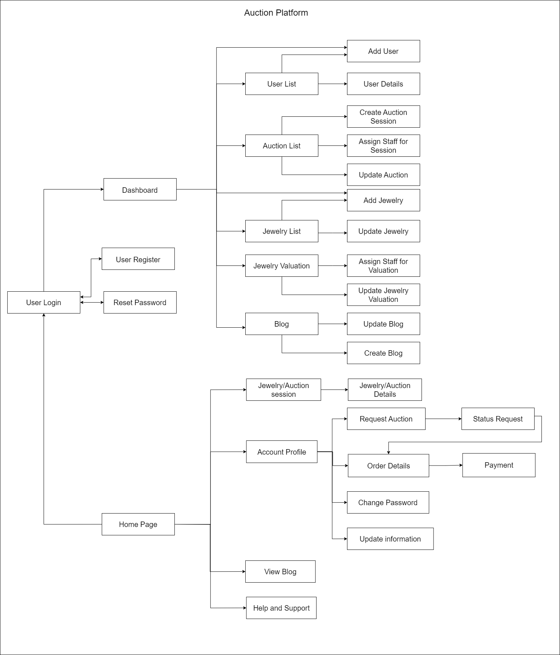

### 

### 

### 2.2 Screen Descriptions

| **#** | **Feature** | **Screen** | **Description** |
| --- | --- | --- | --- |
| 1 | Request for auction | Wishlist | To create an auction you need to request to validate a piece of jewelry. |
| 2 | Auction session | Jewelry/Auction session | View all the auctions in progress and jewelry coming for auction. |
| 3 | View Details | Jewelry/Auction Details | View details jewelry/auction in coming |
| 4 | Join Auction | Join Auction | Joining an auction to start bidding. |
| 5 | Place bid | Bidding | Start an bidding for an auction |
| 6 | Payment Gateway | Payment | Payment Gateway: Securely processes payments, supports various methods, and confirms transactions. |
| 7 | View Profile | Account Profile | View Profile for update and change information for an account. |
| 8 | Blog | View Blog | View Blog information |
| 9 | Create Blog | Post blog | Create a blog |
| 10 | Support | Help and Support | Contact with staff and admin for supporting |
| 11 | Sign In | Sign In | User can login into website |
| 12 | Sign Up | Sign Up | User can create a new account |
| 13 | Request Jewelry | Request Jewelry | User can post their jewelry |
| 14 | My Jewelry | Wishlist | List all user’s jewelry |
| 15 | My Auction | Wishlist | List all user’s auction |
| 16 | Wishlist | Wishlist | List all wishlist |
| 17 | My Profile | My Profile | View all the information of user, can edit and post image |

### 2.3 Screen Authorization

| **Screen** | **Guest** | **Member** | **Staff** | **Manager** | **Admin** |
| --- | --- | --- | --- | --- | --- |
| **Home page** | X | X | X | X |  |
| **Jewelry/Auction session** | X | X | X | X |  |
| View incoming auction | X | X | X | X |  |
| View in progress auction | X | X | X | X |  |
| **View jewelry/auction detail** |  | X | X | X |  |
| Accept license |  | X |  |  |  |
| Place bid |  | X |  |  |  |
| View auction participants |  | X |  |  |  |
| View bid history |  | X |  |  |  |
| **Search for jewelry** | X | X | X | X |  |
| **Blog** | X | X | X | X |  |
| View blog post | X | X | X | X |  |
| Post blog |  | X | X |  |  |
| **Request auction** |  | X |  |  |  |
| Enter product information |  | X |  |  |  |
| Request expertise |  | X |  |  |  |
| **Jewelry Valuation** |  |  | X | X | X |
| Confirm delivery for Jewelry in auction |  |  | X | X |  |
| Jewelry Valuation |  |  | X | X |  |
| Send jewelry valuation to manager |  |  | X | X |  |
| Get final jewelry valuation from manager |  |  | X | X |  |
| Send final jewelry valuation to seller |  |  | X | X |  |
| **Auction Management** |  |  |  | X | X |
| View transaction history |  |  |  | X | X |
| Open session |  |  |  | X |  |
| Close session |  |  |  | X |  |
| Stop session |  |  |  | X |  |
| Create auction session |  |  |  | X |  |
| **Jewelry Management** |  |  | X | X | X |
| Add Jewelry |  |  |  | X |  |
| Remove Jewelry |  |  |  | X |  |
| Update Information Jewelry |  |  |  | X |  |
| Approve Jewelry Valuation |  |  |  | X |  |
| **Revenue Management** |  |  |  | X |  |
| **Dashboard** |  |  |  | X | X |
| **User Management** |  |  |  |  | X |
| Add Staff/Manager |  |  |  |  | X |
| Update Staff/Manager |  |  |  |  | X |
| **Payment integration** |  |  |  |  | X |
| **Reporting and Analytics** |  |  |  |  | X |

### 2.4 Non-UI Functions

| **#** | **Feature** | **System Function** | **Description** |
| --- | --- | --- | --- |
| 1 | Security | Access Control | Control the access of user base on their role |
| 2 | Authorization | Access Key | Authorize request of user base on their access key that is saved in local storage after login |
| 3 | API | API integration | Besides API of backend, website also use API of Metals.Dev to take real-time price of gold, silver,... |
| 4 | Error handling | Logging | Save log the activity of user |
| 5 | Email services | Send email | Send email to verify account, reset password |
| 6 | Database Management | CRUD | Create, Read, Update and Delete data activity |

## 3. System High Level Design

### 3.1 Database Design

#### a. Database Schema

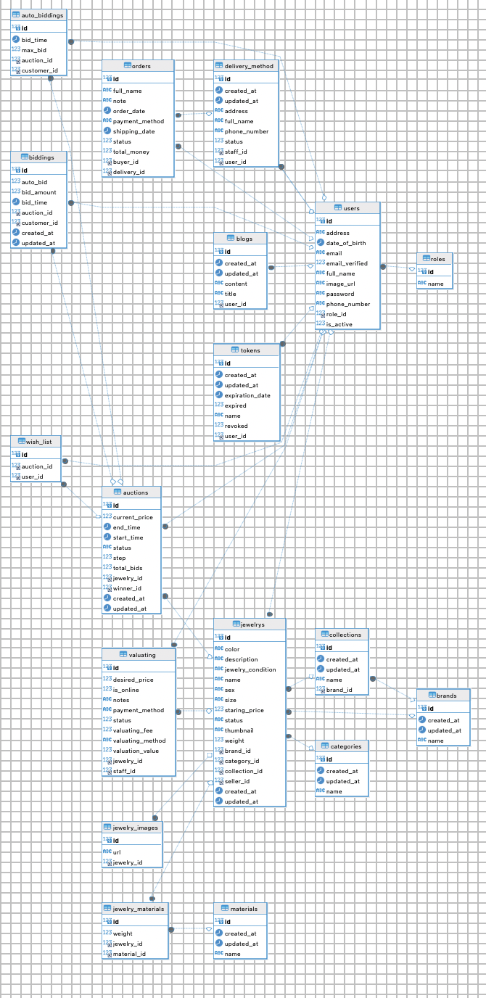

#### b. Table Descriptions

| **No** | **Table** | **Description** |
| --- | --- | --- |
| 1 | material | Contains information about different materials used in products, such as precious metals, gemstones, etc. |
| 2 | categories | Stores categories of products, such as rings, necklaces, bracelets, to classify the items. |
| 3 | brands | This table includes information about the brands of the products, including brand name and description. |
| 4 | collections | Stores information about collections of products, such as summer collection, special edition collections. |
| 5 | jewelrys | Contains detailed information about each piece of jewelry, including name, price, description, and links to categories, brands, and collections if applicable. |
| 6 | jewelry_materials | A junction table managing the materials that make up each piece of jewelry. |
| 7 | jewelrys_images | Stores images of the jewelry, each piece of jewelry may have multiple images. |
| 8 | auctions | Contains information about auctions, including start time, end time, auction status, and the jewelry item being auctioned. |
| 9 | valuating | Manages the appraisal process for jewelry, which may include information about the appraiser, appraisal time, and appraised value. |
| 10 | biddings | Manages information about user bids, including the bid price, bidding time, and links to auctions and users. |
| 11 | auto_biddings | Contains information about automatic bidding settings for users, which automatically place bids when outbid by another user. |
| 12 | delivery_methods | Manages delivery methods for orders, including the method name, fees, and estimated delivery time. |
| 13 | users | Stores user information, including names, emails, passwords, and contact information. |
| 14 | roles | Manages user roles within the system, such as buyer, seller, administrator. |
| 15 | blogs | This table contains blog posts related to products, the market, or advice for users. |
| 16 | order | Manages order information, including product details, buyer information, payment method, and order status. |

### 3.2 Code Packages

Front-end packages:

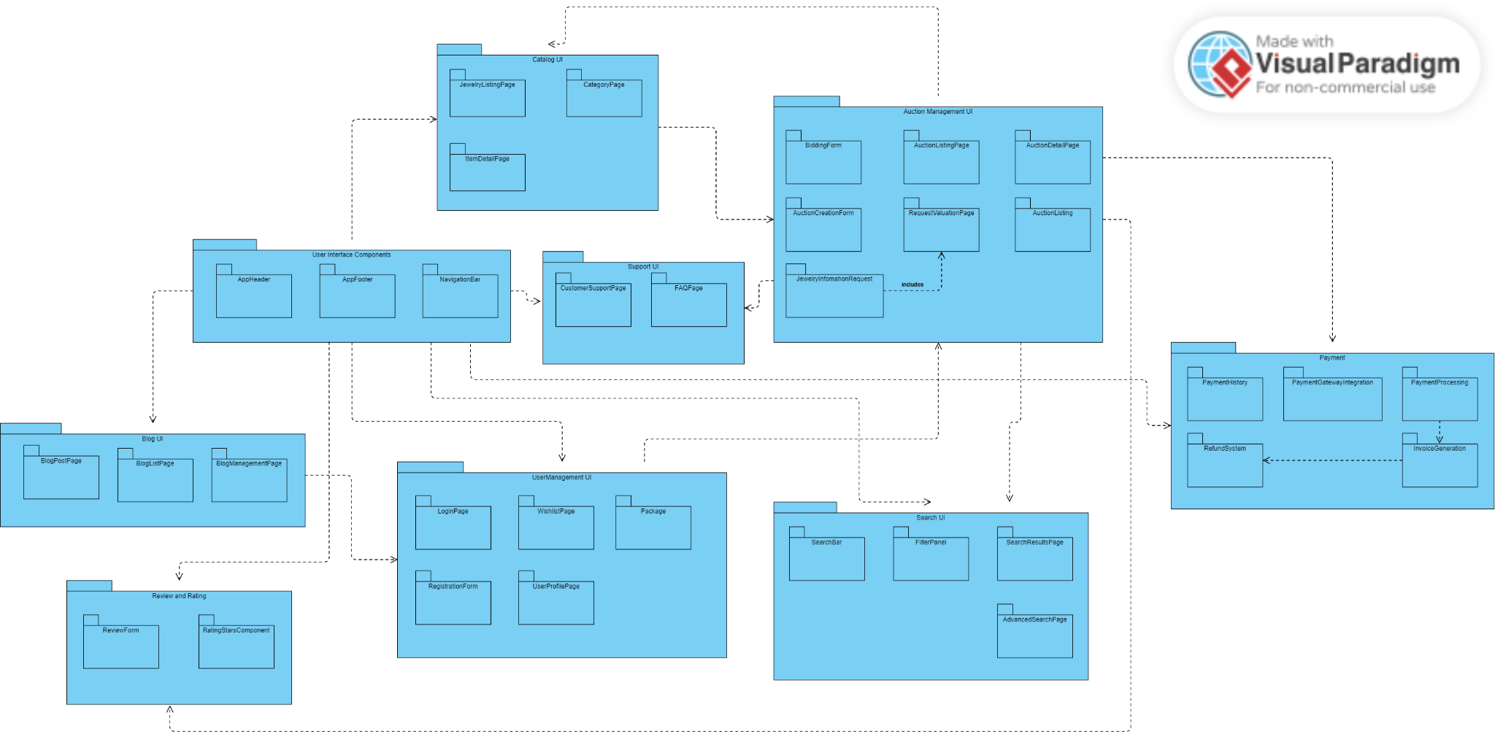

***Package descriptions & package class naming conventions***

| **No** | **Package** | **Description** |
| --- | --- | --- |
| 01 | AppHeader | The header component of the application, containing the logo, navigation links, and possibly user login/logout buttons. |
| 02 | AppFooter | The footer component, featuring links to privacy policy, terms of service, contact information, and social media icons. |
| 03 | NavigationBar | The navigation bar component, providing easy access to different sections of the website, such as home, categories, auctions, support, and user profile. |
| 04 | JewelryListingPage | Displays a list of jewelry items available for auction or purchase, with options to filter and sort the listings. |
| 05 | CategoryPage | Displays jewelry items sorted by categories, such as rings, necklaces, bracelets, etc. |
| 06 | ItemDetailPage | Shows detailed information about a specific jewelry item, including images, description, price, and auction details if applicable. |
| 07 | BiddingForm | The form used by users to place bids on auction items, featuring fields for bid amount and payment method. |
| 08 | AuctionCreationForm | The form used by sellers to create new auctions, including fields for item details, starting bid, reserve price, and auction duration. |
| 09 | AuctionListingPage | Lists all active auctions, with options to filter and sort by various criteria like ending soonest, highest bid, etc. |
| 10 | AuctionDetailPage | Provides detailed information about a specific auction, including current bid, bid history, and a countdown timer to auction end. |
| 11 | RequestValuationPage | Allows users to request a valuation for their jewelry items, featuring a form to submit item details and photos. |
| 12 | JewelryInformationRequest | The form used to request more information about a specific jewelry item, including fields for contact information and specific queries. |
| 13 | CustomerSupportPage | Provides contact information and a form for users to submit support requests or inquiries. |
| 14 | FAQPage | Displays frequently asked questions and their answers to help users with common issues. |
| 15 | LoginPage | The login page for users to access their accounts, featuring fields for username/email and password. |
| 16 | RegistrationForm | The form used for new users to create an account, including personal information, account details, and address information. |
| 17 | WishListPage | Displays a list of items that the user has added to their wishlist. |
| 18 | Package (User Account Package) | A collection of pages and components related to managing the user's account, including profile, payment history, and wishlist. |
| 19 | UserProfilePage | Allows users to view and edit their personal information, such as name, email, phone number, and address. |
| 20 | PaymentHistory | Displays a history of all payments made by the user, including bids, purchases, and refunds. |
| 21 | PaymentGatewayIntegration | The integration with external payment gateways to process transactions. |
| 22 | PaymentProcessing | Handles the processing of payments, including bid payments and purchase transactions. |
| 23 | RefundSystem | Manages refunds for canceled auctions or returned items. |
| 24 | InvoiceGeneration | Generates invoices for completed transactions, available for download or email. |
| 25 | SearchBar | A search input field allowing users to search for jewelry items, auctions, and blog posts. |
| 26 | FilterPanel | Provides options to filter search results by various criteria such as price, category, and auction status. |
| 27 | SearchResultPage | Displays the results of a search query, with options to sort and filter the results. |
| 28 | AdvancedSearchPage | Offers more detailed search options, allowing users to refine their search with multiple criteria. |
| 29 | BlogPostPage | Displays a single blog post with its content, images, and comments. |
| 30 | BlogListPage | Lists all blog posts, with options to filter by categories or tags. |
| 31 | BlogManagementPage | An admin interface for managing blog posts, including creating, editing, and deleting posts. |
| 32 | ReviewForm | The form used by users to submit reviews for jewelry items or auctions. |
| 33 | RatingStarComponent | A star rating component allowing users to rate items or auctions from 1 to 5 stars. |

Back-end packages:

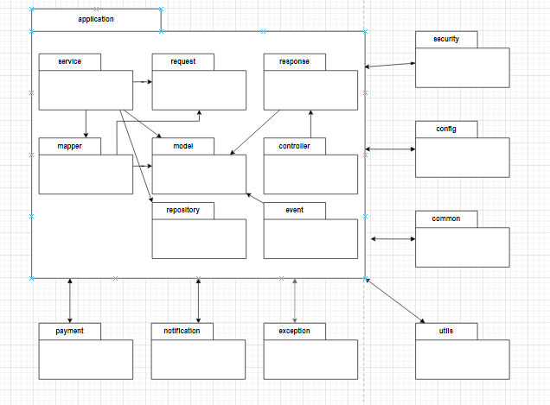

***Package descriptions & package class naming conventions***

| **No** | **Package** | **Description** |
| --- | --- | --- |
| 01 | controller | This package typically contains classes annotated with @Controller or @RestController. Controllers handle incoming HTTP requests, process them, and return appropriate responses. They act as the entry point for user interactions with your application. |
| 02 | service | The service package holds classes annotated with @Service. These classes contain the business logic of your application. They handle complex operations, coordinate with repositories, and provide a higher level of abstraction to controllers. |
| 03 | repository | The repository package contains classes annotated with @Repository. These classes are responsible for database interactions. They encapsulate the logic for retrieving and storing data from/to the database. |
| 04 | model | The model package holds classes representing the data structure of your application. These classes are often used as entities for database tables or as DTOs (Data Transfer Objects) to transfer data between layers. |
| 05 | request | The request package contains classes representing incoming HTTP requests. These classes often map to the structure of the incoming JSON or form data and are used to bind request parameters. |
| 06 | response | The response package contains classes representing the structure of the data sent back in HTTP responses. These classes are used to format and send data to clients in a standardized way. |
| 07 | mapper | The mapper package contains classes responsible for mapping data between different layers of your application. This can include converting entities to DTOs or vice versa. |
| 08 | event | The event package contains classes related to the event-driven architecture. These classes handle and respond to application events or can be used for implementing the Observer pattern. |
| 09 | security | The security package contains classes related to the security configuration of your application. This includes classes for authentication, authorization, and other security-related concerns. |
| 10 | config | The config package contains classes related to the configuration of your application. This includes Spring configuration classes, beans, and other configuration-related components. |
| 11 | common | The config package contains classes related to the many common variables, some function is usually used in the controller class. |
| 12 | utils | The utils package typically contains utility classes that provide general-purpose functions and are not specific to any particular layer or domain. |
| 13 | exception | The exception package contains custom exception classes or handlers for handling exceptions in your application. |
| 14 | notification | The notification package contains classes related to sending notifications, such as emails or push notifications. |
| 15 | payment | The payment package contains classes related to payment processing, including payment gateway integrations and handling financial transactions. |

# II. Requirement Specifications

| **ID** | **Business Rule** | **Business Rule Description** |
| --- | --- | --- |
| 1 | Sign Up | Users must have an identity card to register for an account |
| 2 | Sign In | Users are required to log in to participate in the auction |
| 3 | authentication | Sellers must have jewelry authentication certificate |
| 4 | Valuation for Jewelry | The seller offers a starting price and  buy it know (max price) |
| 5 | Expertise | Before the product is approved to be listed on the auction floor, the seller must pay appraisal costs to the auction system. |
| 6 | Delivery | If the seller agrees with the price offered by the system, the product will be shipped for free. If not, the seller will have to bear the shipping fee to the appraisal company. |
| 7 | License | Before participating in the auction, user must read and confirm the terms and conditions carefully to clearly understand the rules of the game |
| 8 | Rules for bid | Bidders must comply with the jump set by the seller |
| 9 | Rules for pay | When the auction is successful, the buyer must pay in full or their account will be locked forever |
| 10 | Fees for systems | Both the buyer and the seller must pay intermediary fees to the auction system |
| 11 | time for refund or return | When completing the payment procedure, the buyer will receive the jewelry. Within 3 days, if there are no complaints, the money will be paid by the system to the seller. |

## Search for jewelry

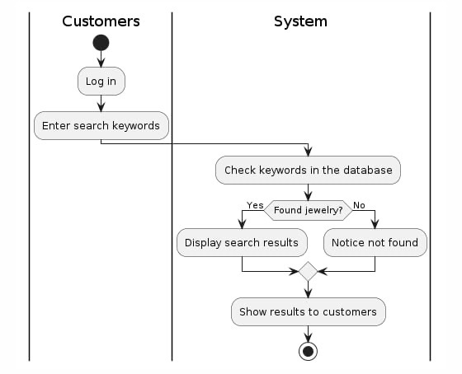

## View coming auction

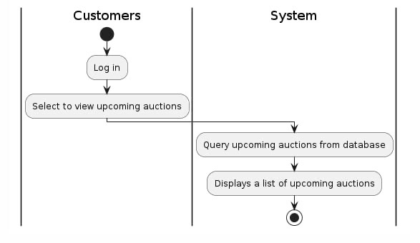

## View blog

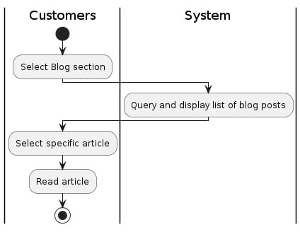

## Sign In

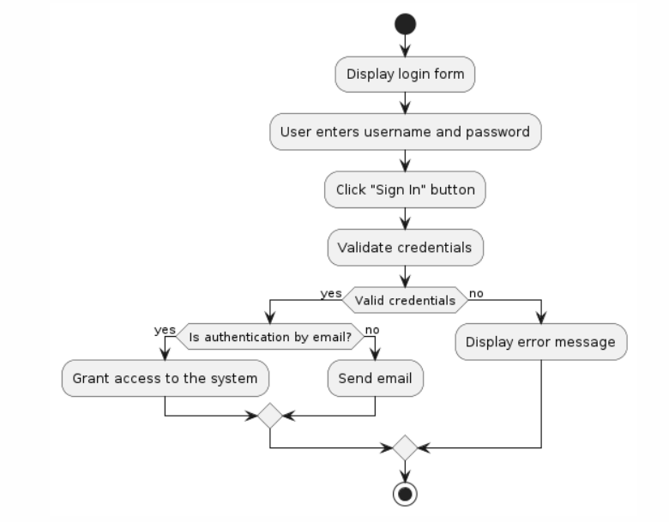

## Signs Up

## 

## Removes jewelry

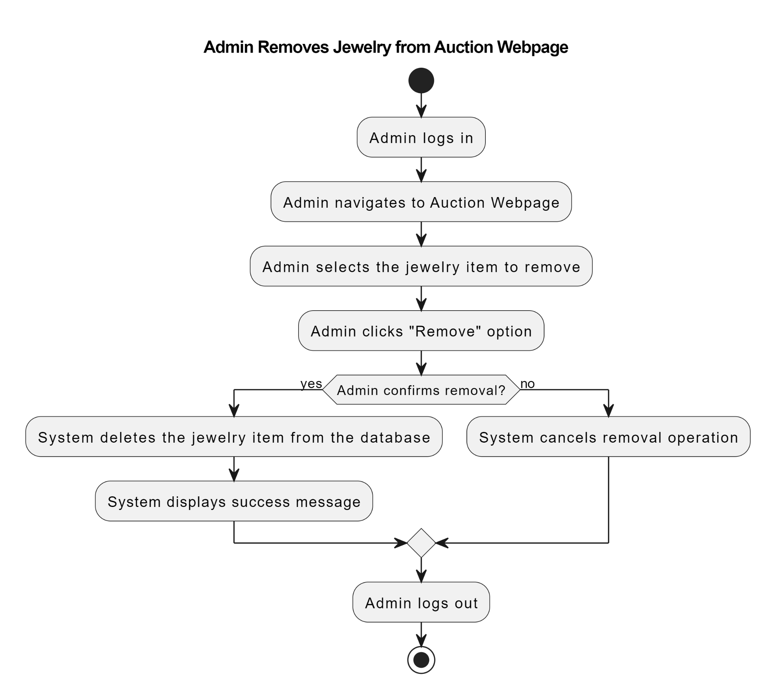

## Create blog

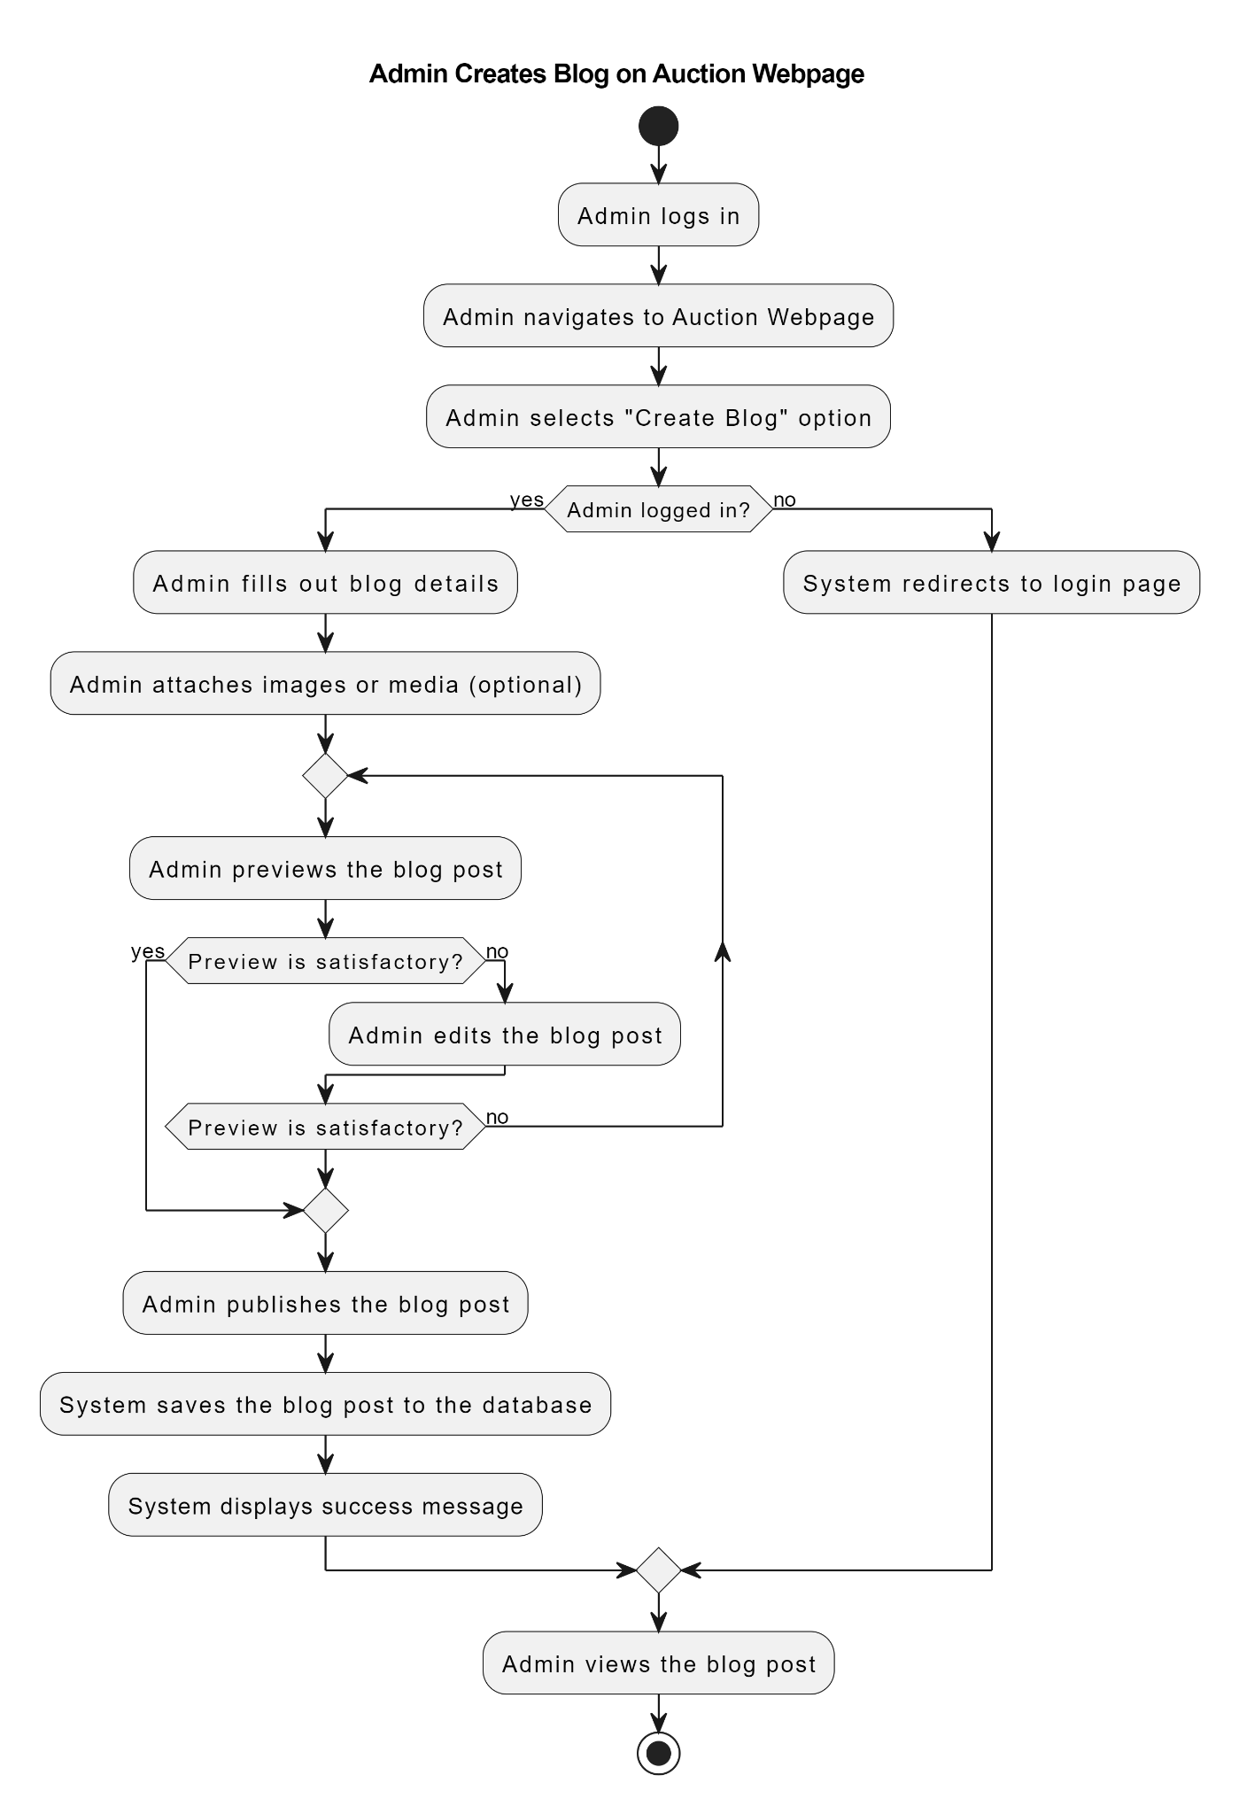

## update information jewelry

## View Information

## Jewelry Valuation

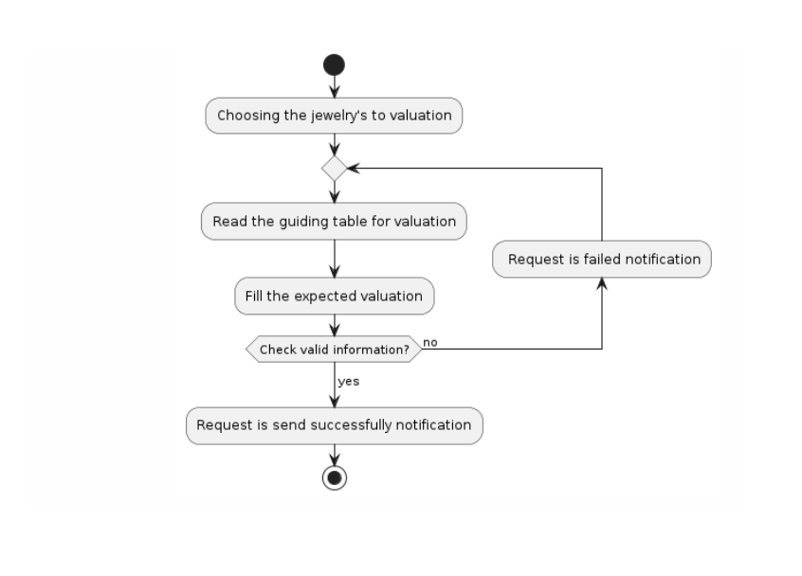

## Approve Valuation

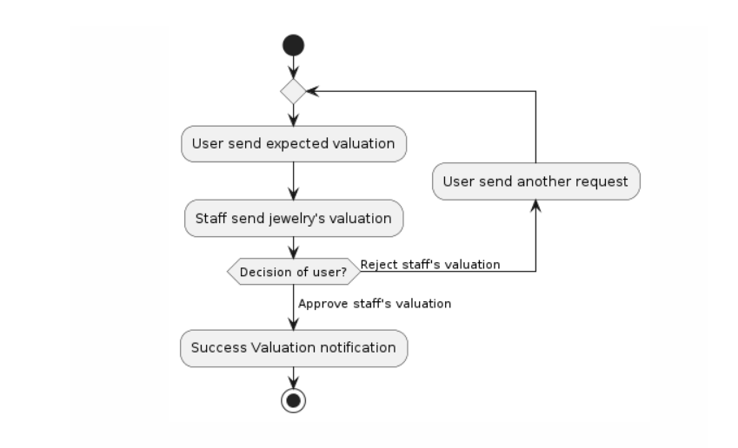

## Add new staff/manager

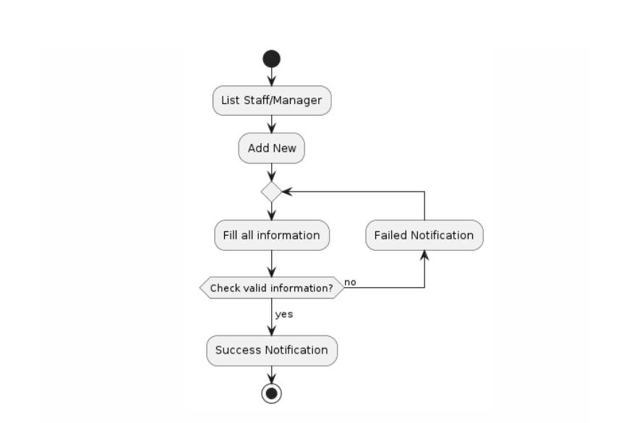

## Update staff/manager

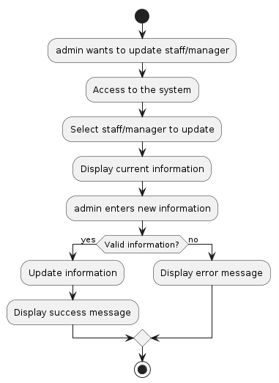

## View bid history

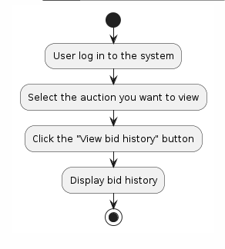

## Send jewelry valuation to manager

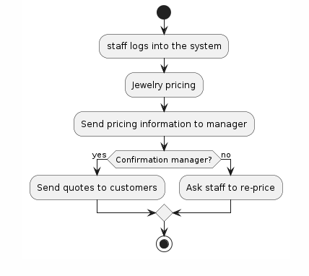

# III. Design Specifications

## 1. Authentication

### 1.1 Sign In

#### a.User login

This screen allow user to login into the website to interact with the authorize feature/functionality

##### UI Design

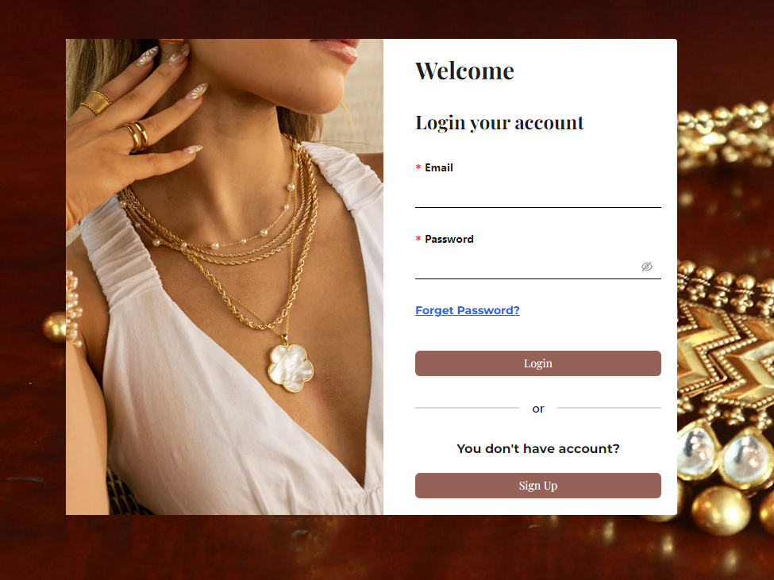

| **Field Name** | **Field Type** | **Description** |
| --- | --- | --- |
| Email | Text box | This field allow user to input valid email |
| Password | Text box | This field allow user to input password |
| Forgot Password | Link modal | This field allow user enter their email to request reset password via email |
| Login | Button | Allow user login to website after enter email and password |
| Sign up | Button | Allow user move to sign up page |

##### Database Access

| **Table** | **CRUD** | **Description** |
| --- | --- | --- |
| UsersEntity | R | Check the account is existed to sign in to website |

***SQL Commands***

*[Provide the detailed SQL (select, insert, update...) which are used in implementing the screen/function]*

### 1.2 Sign Up

#### a.User sign up

This screen allow user to register an account

##### UI Design

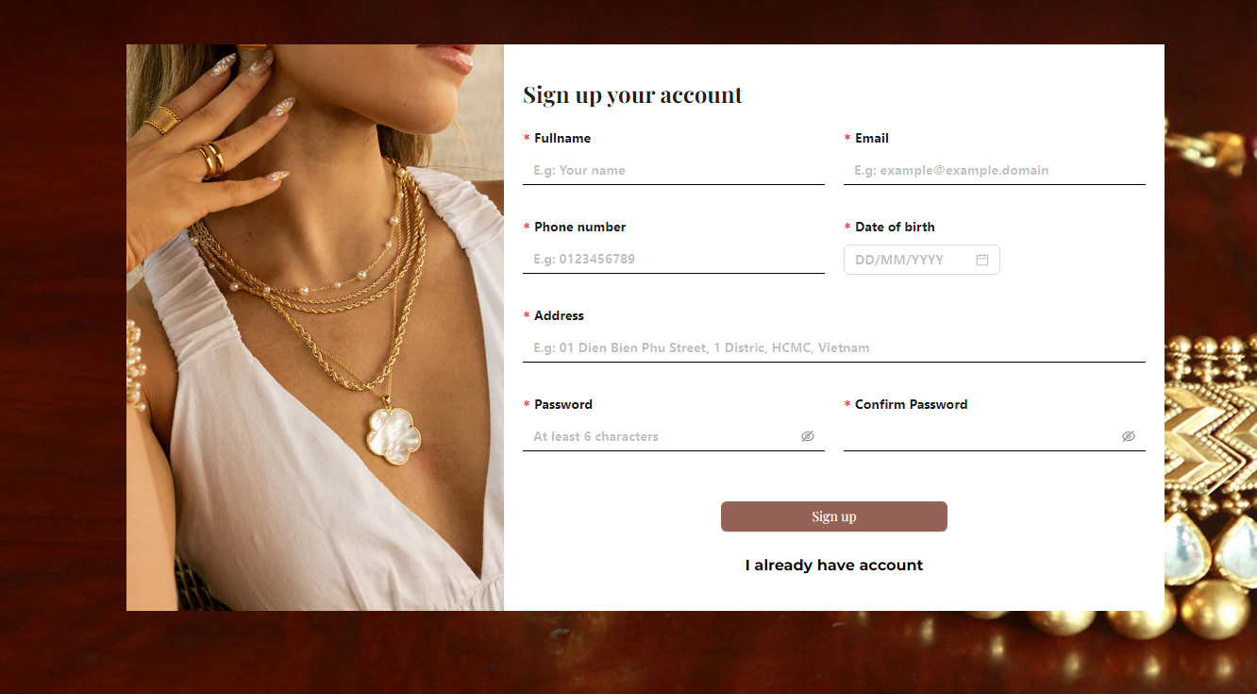

| **Field Name** | **Field Type** | **Description** |
| --- | --- | --- |
| ***Field Group Name*** | | |
| Full Name | Text box | This field allow user to input valid full name |
| Email | Text box | This field allow user to input valid email |
| Phone number | Text box | This field allow user to input valid phone number |
| Date of birth | Date (DD/MM/YYYY) | This field allow user to input valid date |
| Address | Text box | This field allow user to input a valid address |
| Password | Text box | This field allow user to input a valid password |
| Confirm Password | Text box | This field allow user to input a valid same as password field |

##### Database Access

| **Table** | **CRUD** | **Description** |
| --- | --- | --- |
| UsersEntity | C | Create an account for user |

***SQL Commands***

## 2. Product

### 2.1 Request jewelry

#### a. Create jewelry

This page allow user to input information of jewelry

##### UI Design

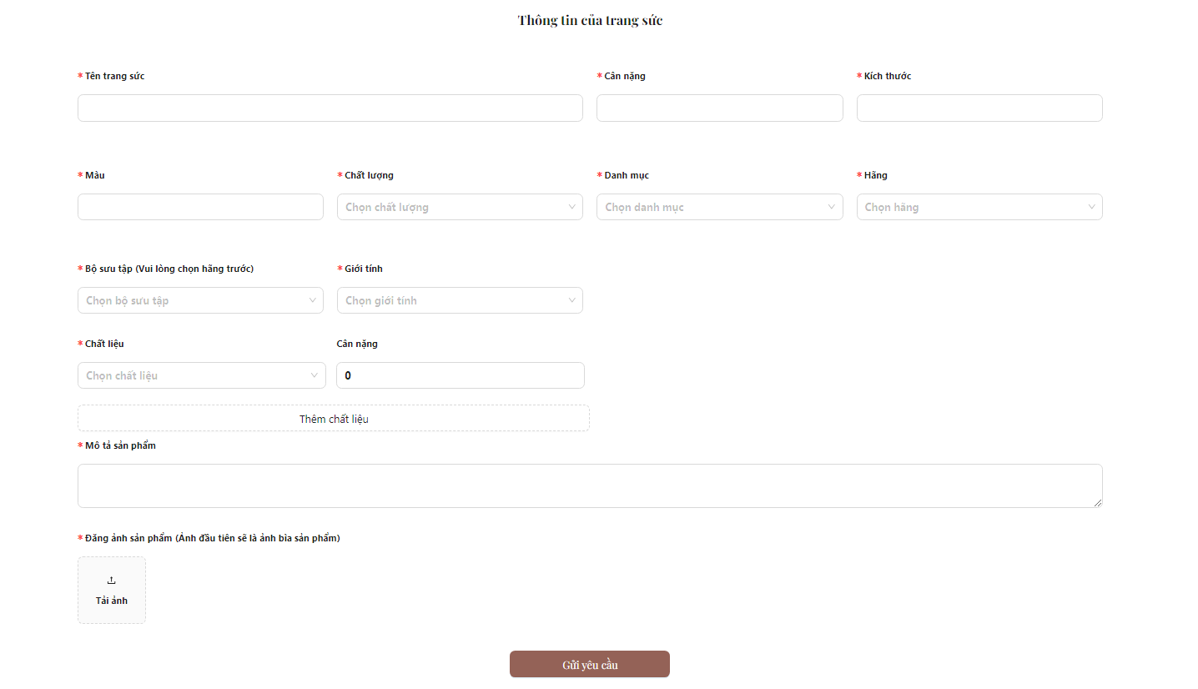

| **Field Name** | **Field Type** | **Description** |
| --- | --- | --- |
| ***Field Group Name*** | | |
| Tên trang sức | Text box | This field allows the user to input jewelry name |
| Cân nặng | Text box | This field allows the user to input jewelry weight |
| Kích thước | Text box | This field allows the user to input jewelry size |
| Màu | Text box | This field allows the user to input jewelry color |
| Chất lượng | ComboBox | This field allows the user to input jewelry condition |
| Danh mục | ComboBox | This field allows the user to input jewelry category |
| Hãng | ComboBox | This field allows the user to input jewelry brand |
| Bộ sưu tập | ComboBox | This field allows the user to input jewelry collection |
| Giới tính | ComboBox | This field allows the user to input jewelry be suitable to sex |
| Chất liệu | ComboBox | This field allows the user to input jewelry material |
| Cân nặng | Text Box Float | This field allows the user to input jewelry weight for each material. |
| Mô tả sản phẩm | Text box | This field allows the user to input jewelry description |
| Ảnh sản phẩm | Image | This field allows the user to input jewelry image |
| Gửi yêu cầu | Button | User clicks to create new jewelry with the above information. |

##### Database Access

| **Table** | **CRUD** | **Description** |
| --- | --- | --- |
| JewelryEntity | C | Create new jewelry |

***SQL Commands***

#### INSERT INTO jewelrys (color, description, jewelry_condition, name, sex, size, staring_price, weight, brand_id, category_id, collection_id, seller_id, thumbnail)

#### VALUES (?, ?, ?, ?, ?, ?, ?, ?, ?, ?, ?, ?, ?),

#### 

#### b. User manage jewelry

Allowing user to manage their jewelry

##### UI Design

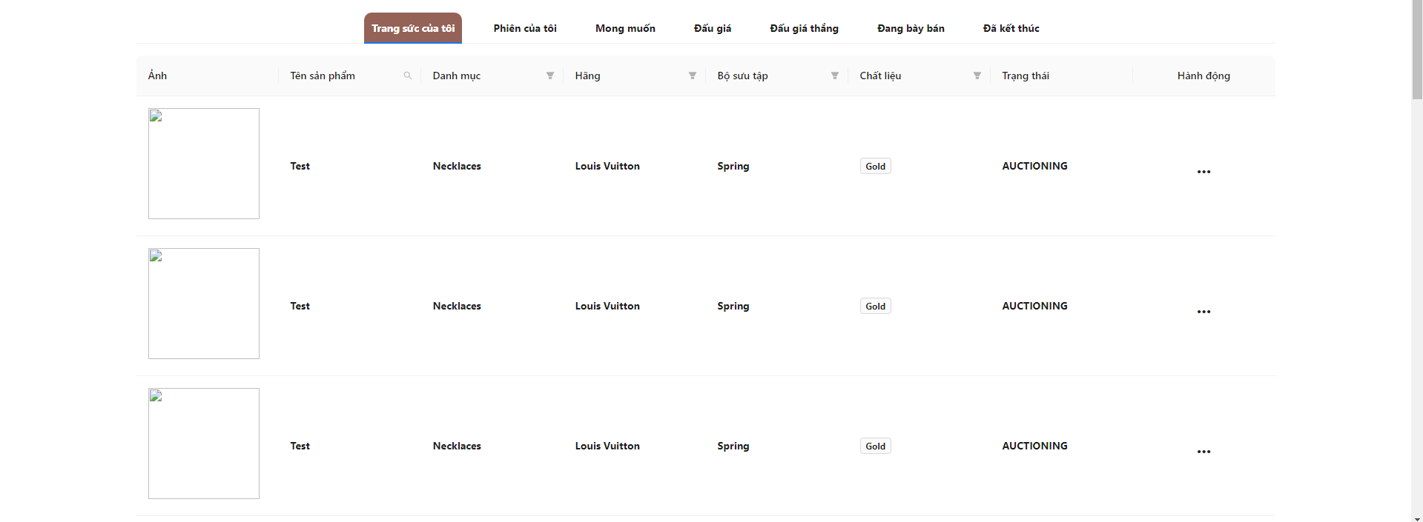

| **Field Name** | **Field Type** | **Description** |
| --- | --- | --- |
| ***Field Group Name*** | | |
| Ảnh | Text | Image of the jewelry product |
| Tên sản phẩm | Text | Name of the jewelry product |
| Danh mục | Text | Category of the jewelry product |
| Hãng | Text | Brand of the jewelry product |
| Bộ sưu tập | Text | Collection to which the jewelry product belongs |
| Chất liệu | Label | Main material used to make the jewelry product |
| Trạng thái | Text | Current status of the jewelry |
| Hành động | Action | Actions that can be performed on the jewelry |

##### Database Access

| **Table** | **CRUD** | **Description** |
| --- | --- | --- |
| Jewelry | R | List up jewelry |

### 2.2 Auction

#### a. Create auction

This screen will allow user enter information to put up to auction

##### UI Design

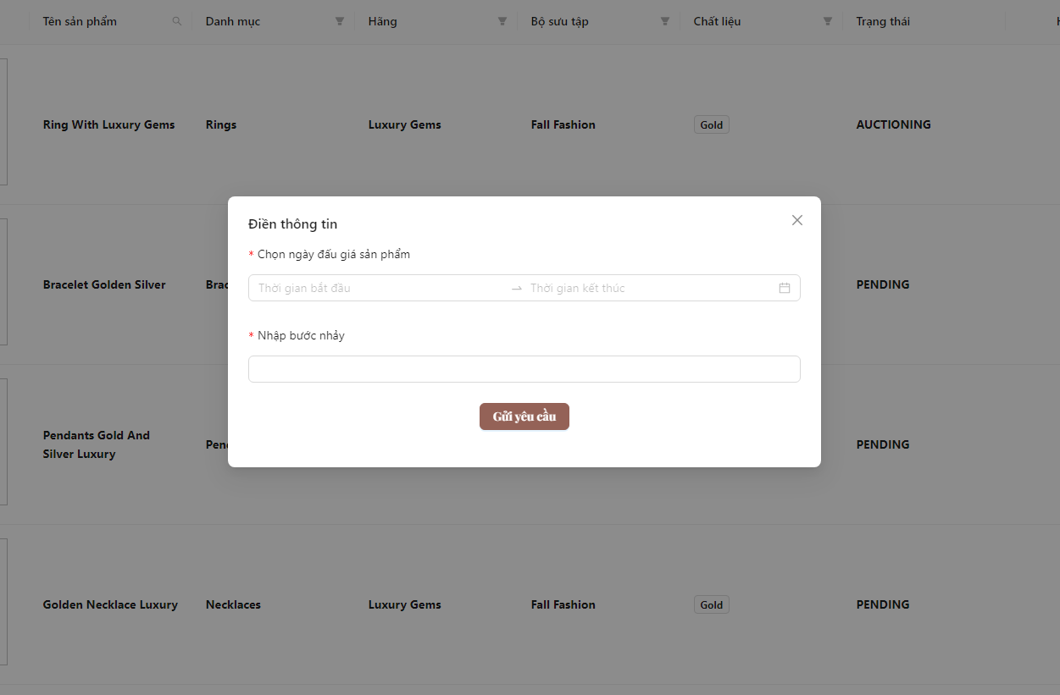

| **Field Name** | **Field Type** | **Description** |
| --- | --- | --- |
| Thời gian bắt đầu | Date Picker | This field allow user choose start date of auction |
| Thời gian kết thúc | Date Picker | This field allow user choose end date of auction |
| Nhập bước nhảy | Number Box | This field allow user enter step of auction |
| Gửi yêu cầu | Button | Send request auction |

##### Database Access

| **Table** | **CRUD** | **Description** |
| --- | --- | --- |
| AuctionsEntity | C | Putting up jewelry to auction session |

#### b. View user auction

User can manage their auction they put up to website

##### UI Design

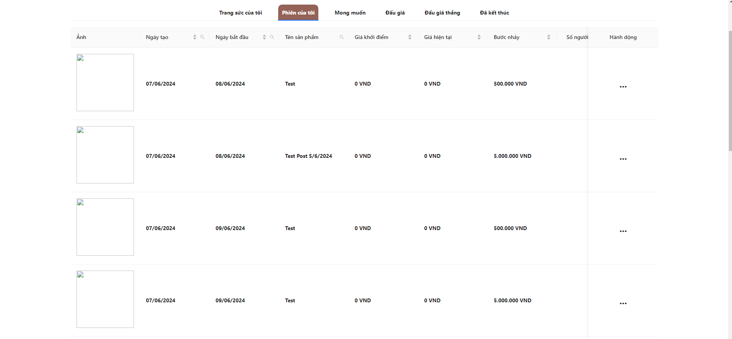

| **Field Name** | **Field Type** | **Description** |
| --- | --- | --- |
| ***Field Group Name*** | | |
| Email | Text box | This field allow user to input valid email |
| Password | Text box |  |

##### Database Access

| **Table** | **CRUD** | **Description** |
| --- | --- | --- |
| Auction | R | List-up auction that user owns |

3. Admin

*3.1 Jewelries Management*

1. view Jewelries

This screen will display all jewelries currently in the system

**UI Design**

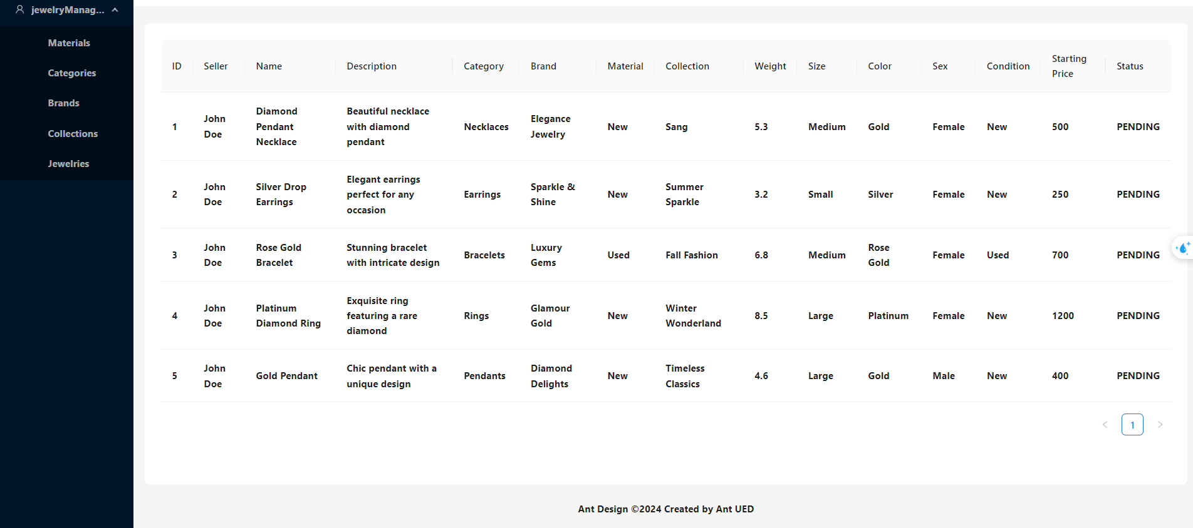

| **Field Name** | **Field Type** | **Description** |
| --- | --- | --- |
| Seller | Text | Name of the seller |
| Name | Text | Name of Jewelry |
| Description | Text | Detailed description of the jewelry |
| Category | Text | Type of Jewelry |
| Brand | Text | Name of Brand |
| Material | Text | Name of Material |
| Collection | Text | Collection of Jewelry |
| Weight | Text | Weight of Jewelry |
| Size | Text | Size of Jewelry |
| Color | Text | Color of Jewelry |
| Sex | Text | jewelry for male or female |
| Condition | Text | Condition of Jewelry |
| Starting Price | Text | starting price at auction |
| Status | Text | status of jewelry |

### 

### 3.2 Collections Management

1. View Collections

This screen will display all collections currently in the system

**UI Design**

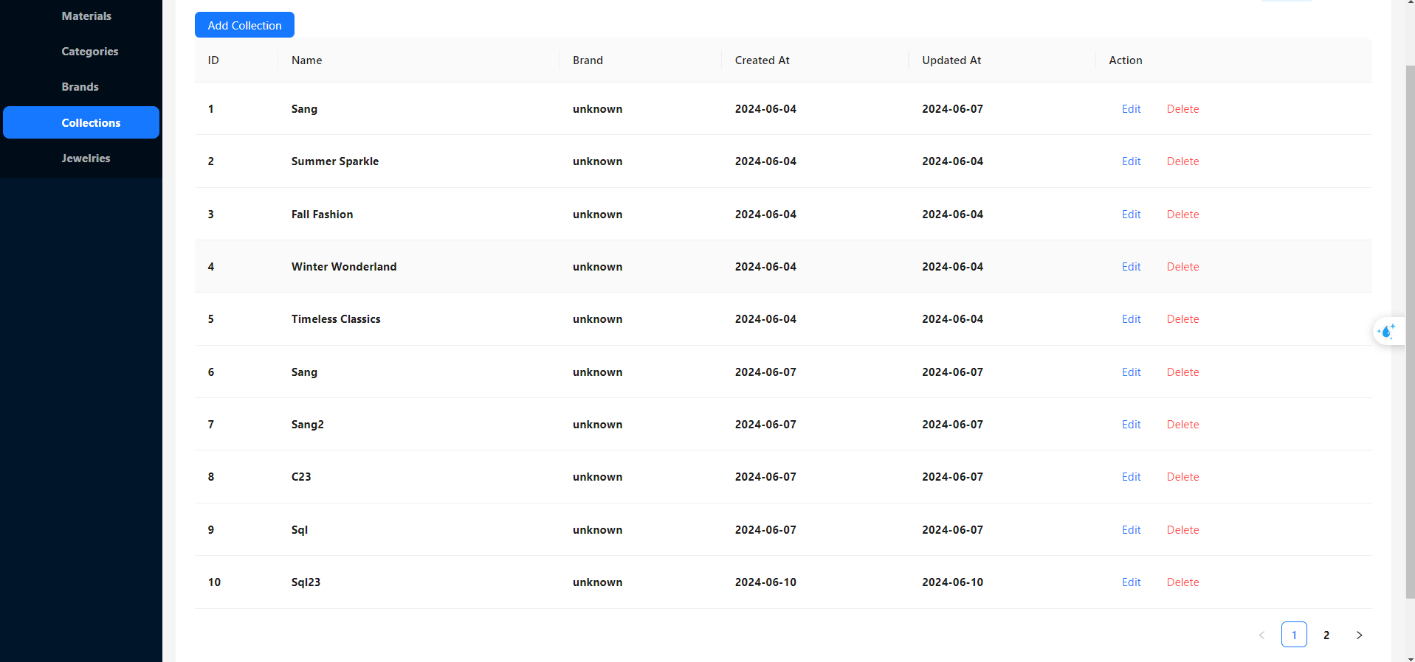

| **Field Name** | **Field Type** | **Description** |
| --- | --- | --- |
| Name | Text | Name of collection |
| Brand | Text | Name of Brand |
| Created At | Text | Brand creation Time |
| Updated At | Text | Brand updation Time |

1. Add Collection

This screen will allow admin create the collection for the system

**UI Design**

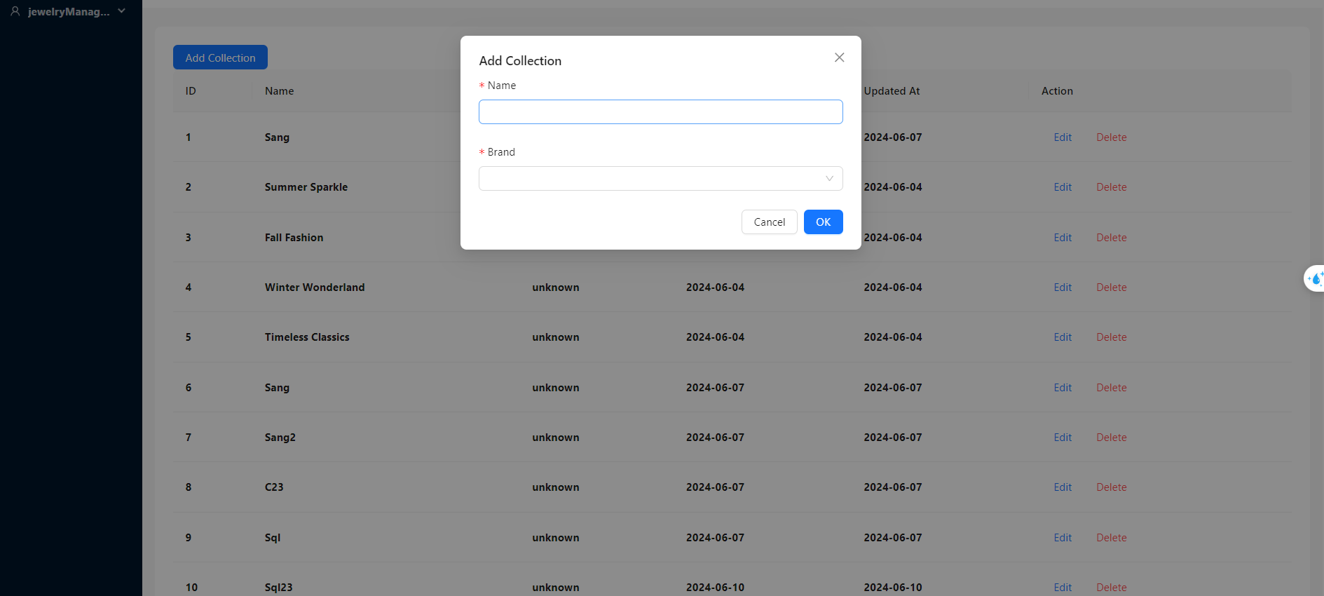

| **Field Name** | **Field Type** | **Description** |
| --- | --- | --- |
| Name | Text | This field allow admin to name of Collections |
| Brand | Text | This field allow admin to name of Brand |

1. Edit Collection

This screen will allow admin edit the collection for the system

**UI Design**

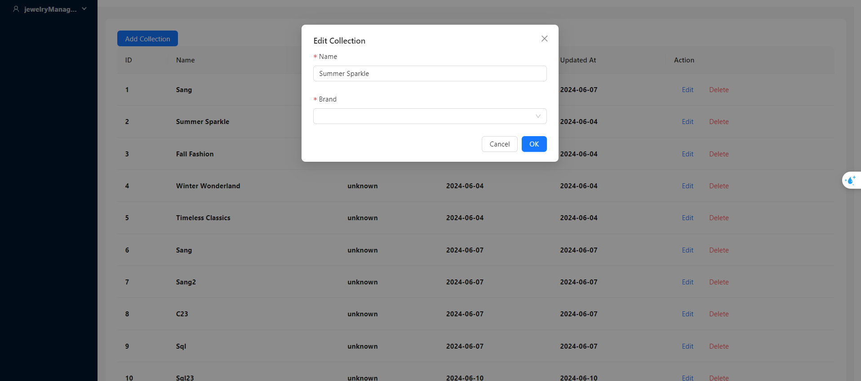

| **Field Name** | **Field Type** | **Description** |
| --- | --- | --- |
| Name | Text | This field allow admin to edit Name of Collections |
| Brand | Text | This field allow admin to edit Name of Brand |

# IV. Appendix

## 1. Assumptions & Dependencies

1. Assumptions (AS):
   * **AS-1:** A user-friendly web interface will be available for bidders to participate in the auction.
   * **AS-2:** Jewelry items will be accurately described and displayed on the website.
   * **AS-3:** Bidders will have access to secure payment methods for successful bids.
   * **AS-4:** The auction platform will handle expected traffic volumes efficiently.
2. Dependencies (DE):
   * **DE-1:** Integration with third-party payment gateways for secure transactions.
   * **DE-2:** Reliable hosting and server infrastructure to support the auction website.
   * **DE-3:** Legal compliance with auction regulations and policies.

## 2. Limitations & Exclusions

## 3. Business Rules

| **ID** | **Business Rule** | **Business Rule Description** |
| --- | --- | --- |
| 1 | Sign Up | Users must have an identity card to register for an account |
| 2 | Sign In | Users are required to log in to participate in the auction |
| 3 | authentication | Sellers must have jewelry authentication certificate |
| 5 | Valuation for Jewellery | The seller offers a starting price and  buy it now (max price) |
| 4 | quick valuation | The website will provide tools for users to calculate product prices themselves  quick valuation |
| 6 | Expertise | Before the product is approved to be listed on the auction floor, the seller must pay appraisal costs to the auction system. |
| 7 | Delivery | If the seller agrees with the price offered by the system, the product will be shipped for free. If not, the seller will have to bear the shipping fee to the appraisal company. |
| 8 | Auction opening time | Sellers have the right to open their own auctions to flexibly bid. |
| 9 | License | Before participating in the auction, users must read and confirm the terms and conditions carefully to clearly understand the rules of the game. |
| 10 | Rules for bid | Bidders must comply with the jump set by the seller. |
| 11 | Rules for pay | When the auction is successful, the buyer must pay in full or their account will be locked forever. |
| 12 | Fees for systems | Both the buyer and the seller must pay intermediary fees to the auction system. |
| 13 | time for refund or return | When completing the payment procedure, the buyer will receive the jewelry. Within 3 days, if there are no complaints, the money will be paid by the system to the seller. |
| 14 | cancel the auction | The seller has the right to cancel the transaction if the price they desire has not been reached. |
| 15 | Terms for canceling transactions | Sellers and buyers will have their reputation points deducted if they cancel the transaction  If the number of transaction cancellations exceeds 5 times in 1 month, the account will be permanently banned. |

## 